1. Applications of Clustering Algorithm are as follows

* **Recommendation Engines** : The recommendation engines used in Amazon ,Flipkart etc.
* **Market and Customer Segmentation** : A telecom company makes a cluster of prepaid users to understand the pattern/behaviour in the form of recharging amount, sending SMS, and using the internet .
* **Search Results** : Google search engine uses clustering to suggest similar search results while typing in search box.
* ****Biological Data Analysis, Medical Imaging Analysis and Identification of Cancer Cells****
* **Identifying Spam Mails** : Clustering is used to identify spam mails.

1. As the value of K increases the value of Objective function for K-Means **Decreases** non-linearly .

* As K increases no of points in a cluster decreases and the points are closer to its cluster centre and hence distance is less , therefore ${|x_{i}−c_{i}| }^{2}$ decreases for every point in space and objective function value is decreased . If we have no of clusters k equal to no of points in space then we will have distortion function as zero since every point will be cluster centre of its own.

1. After applying K-Means to the data set provided we get the following results .

1)

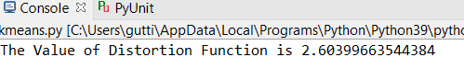

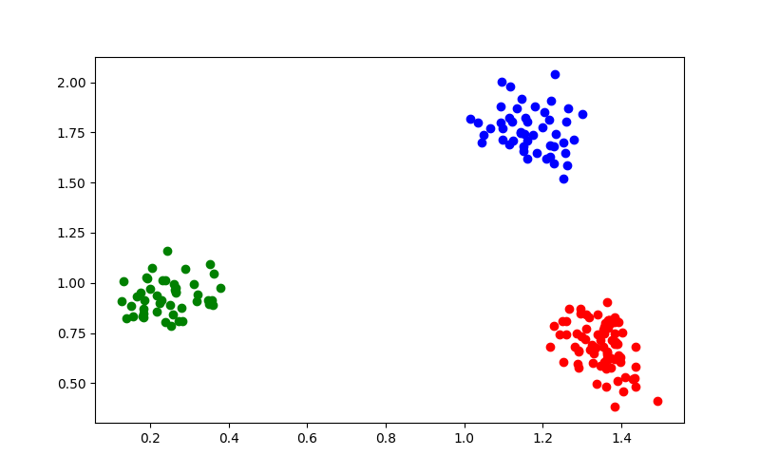

The three different colors represent three different clusters.

Hence the value of the distortion function for the given data set is = **2.60399663544384**

The code for the above output is as follows

import matplotlib.pyplot as plt

import numpy as np

import math

from sklearn.cluster import KMeans

array_txt = np.loadtxt(*r"C:\Users\gutti\Downloads\A.txt"*,usecols=(0, 1), skiprows=1)

df = array_txt[:,0:2]

kmeans = KMeans(n_clusters=3, random_state=100)

kmeans.fit(df)

y_kmeans = kmeans.predict(df)

print(*'The Value of Distortion Function is'* ,kmeans.inertia_)

plt.figure(figsize = (8,5))

plt.scatter(df[y_kmeans == 0 ,0 ] ,df[y_kmeans == 0,1 ], c = *'red'*)

plt.scatter(df[y_kmeans == 1 ,0] ,df[y_kmeans == 1,1 ] , c = *'green'*)

plt.scatter(df[y_kmeans == 2 ,0] ,df[y_kmeans == 2,1 ] , c = *'blue'*)

plt.show()

*''''x=[] #distortion function is calculated as follows*

*for m in range(0,3) :*

*x.append(df[y_kmeans == m])*

*sum = 0*

*for i in range(0,3) :*

*for j in range(0,len(x[i])) :*

*sum =sum + math.pow(math.dist(x[i][j] , kmeans.cluster_centers_[i]),2)*

*print(sum)'''*